Physioactive newsletter
  - September - October 2014
Andrew Rolph

Andrew recently joined the team as an Exercise Physiologist, working alongside Lauren Postans. His interests include: musculoskeletal rehabilitation, Workcover reconditioning programs, weight management and chronic disease management such as diabetes. Andrew has worked extensively with older adults in falls prevention and strengthening programs. He is available for appointments on Wednesdays.

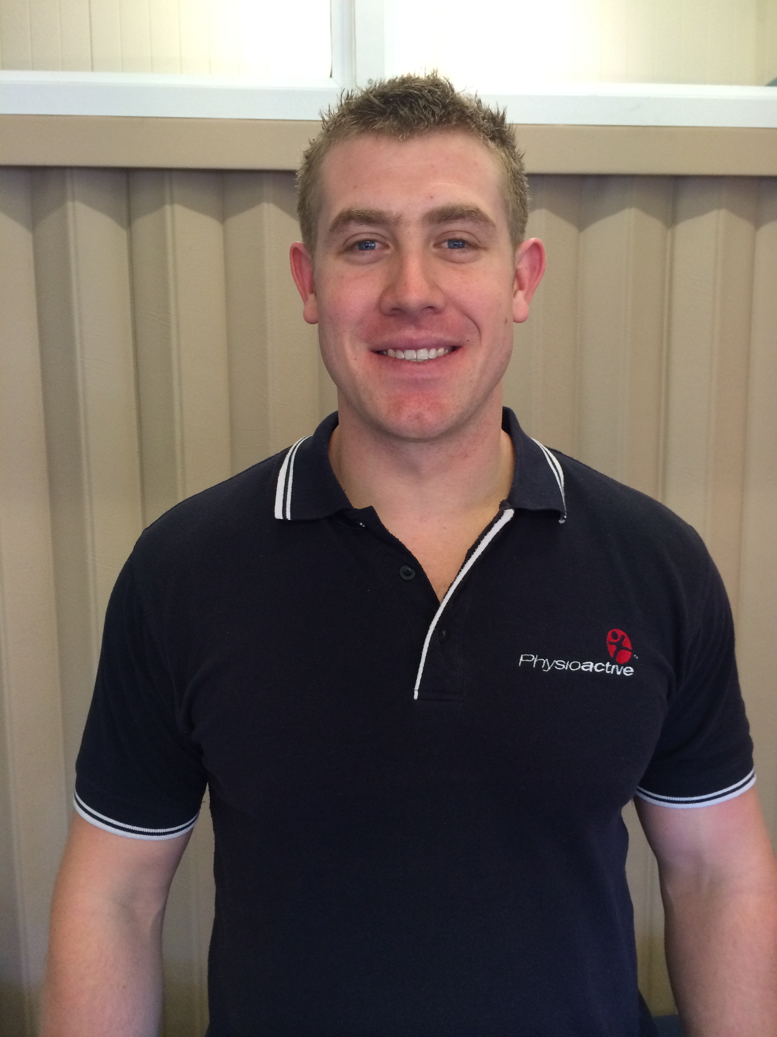
balance and falls prevention
Falls can be caused by many factors and can lead to consequences including injury, psychological stress, functional decline, early nursing home placement and even death. It has been estimated that over 1000 deaths each year are a result of falling.
Several studies have supported physiotherapy intervention as an effective way of preventing falls. Exercise programs for strength, mobility and balance have been shown to significantly decrease the risk of falling, and have the added advantage of improving the strength of the bones helping to lower the probability of a fracture. Although many people think they are too young for these types of exercises, these programs have been shown to be effective across all age groups but are also particularly important for people with diabetes, arthritis or osteoporosis.

Why not join one of our Pilates or Hydrotherapy classes to help improve your strength, flexibility and balance. Exercises can be modified to suit your individual needs.
Sponsorships
Walking aids can also be considered for those whose balance is significantly impaired. Although most people are resistant to using a walking aid as it can make them seem “old and frail” they can have a dramatic impact of levels of independence and mobility. Walking aids should be fitted by a professional so that they are set at the correct height and the correct type of aid is selected (e.g. walking stick or 4 wheel walker).
If you feel that this might apply to you, make an appointment with one of our Physiotherapists and they will be able to assess your mobility, balance and strength. You will be set up with an individualised exercise program that is tailored for your specific needs. If this interests you, see reception to make an appointment with one of the Physiotherapists and ask them about our new class “Bones and Balance” with Lauren (Exercise Physiologist). If you have Private Health you might be able to claim a rebate.
It’s never too early or too late to take control of your health and fitness!

Running and injury prevention
Research Participation
Darrin & Kerryn: UQ Hip study
Darrin & Steve: UQ Knee study
Jets Update:
The Jets have made it into the Finals rounds for the fourth year in a row. We wish them good luck!
Shock Wave Unit:
Physioactive recently purchased a shock wave therapy unit which is used to treat tendon and overuse problems. Ask your Physiotherapist for more details.
Gift Vouchers:
Can’t think of that perfect gift for your special someone? Why not give them a gift voucher that they can use on a massage or a Pilates class?
Dietician:
We are excited to announce Lara Quick will be joining our team soon. She will be available for Saturday appointments once a month.
Available Services:
Pilates
Hydrotherapy
Gym visits
Home visits
Hand therapy
- wound management
- custom made splints
- cast removal
Children’s handwriting
Sports taping
Sports trainer’s evenings
Splints, braces, walking aids

As we start heading into warmer weather it is inevitable that people will start dusting off their joggers and heading out for a walk, jog or a run. In an ideal world this would be a seamless transition with no aches, twinges or lingering soreness from the previous day’s work-out, however most people will have to deal with some form of injury. While most times people don’t think these issues are serious enough to warrant a rest period, if you don’t take a little time off now, it may end up being a long time off later. Common injuries include: “runner’s knee”, Achilles tendonopathy, hamstring problems, plantar fasciitis, shin splints and stress fractures.

Contact Us
Physioactive
8 Roderick Street
Ipswich QLD 4305
Ph:(07) 3281 8876
Fax: (07) 3812 1100
mail@physioactive.com.au
www.physioactive.com.au
Monday – Friday 7am – 7pm
Saturday 8am – 1pm
Pilates Timetable
Monday 5:00 – 6:00pm
Tuesday 4:00 – 5:00pm
5:00 – 6:00pm
6:00 – 7:00pm
Wednesday 10:00 – 11:00am
5:00 – 6:00pm
Thursday 4:45 – 5:45pm
5:45 – 6:45pm
Friday 1:00 – 2:00pm

Individual Pilates sessions can be booked as needed
Hydrotherapy Timetable
Tuesday 7:30 – 9:00am
Friday 7:30 – 9:00am
Group or individual sessions

A basic plan of attack when you notice an issue starting is to decrease your distance and intensity and book in to see a Physiotherapist who can get you started on a treatment program and help you develop a long-term injury prevention strategy that is proactive rather than reactive. The Physiotherapist will do a full assessment to determine which muscles require strengthening or stretching. They will also assess your biomechanics to make sure that you are moving in the safest and most effective way.

benefits of Massage
Therapeutic massage is helpful in the management of emotional and physical stress, anxiety and depression. An immediate benefit of massage is the feeling of relaxation and calmness. This is due to massage prompting the release of endorphins (brain chemicals) that produce the feeling of wellbeing and by reducing the levels of stress hormones. Massage also helps to relax muscle tension, stimulate the flow of blood through the muscles, break down and eliminate toxins, enhance oxygenation of the brain and relax the nervous system.
Massage is also beneficial for improving joint mobility, increasing circulation and enhancing healing of soft tissue injuries. If this interests you make a booking with one of our Remedial Massage Therapists Rowena or Nicole.

