Physioactive newsletter
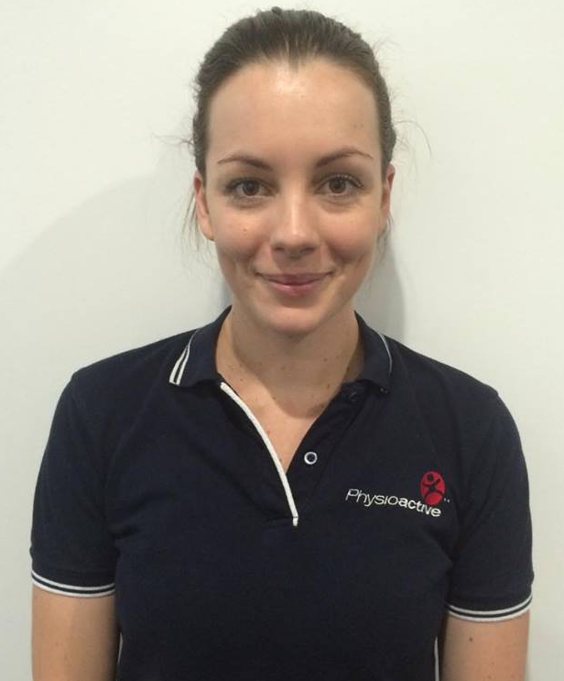
  - January – March 2017

SCHOOL BACK PACKS
Nathan Niesler (Physiotherapist)
Nathan has recently joined our physiotherapy team having previously

With the return of children to school ready for 2017, many parents will purchase new school bags. Research shows a typical school bag can weigh more than five kilograms and incorrect carrying can lead to back, neck and shoulder problems – especially while young spines are maturing. Put simply, heavy loads can cause the body to make abnormal posture adjustments to accommodate the weight of the bag. It is recommended that the packed school bag should not exceed ten percent of the student’s body weight.
graduated from physiotherapy at Griffith University (2012) and Human Movement Studies at QUT (2004).
Nathan has undergone further professional development and has a special interest in the field of spinal, neuropathic pain, headache, migraine and sports injuries. He has also completed training at the Watson Headache Institute in Sydney.
Nathan is available for appointments from Monday to Friday.

Make smart decisions now to avoid posture related injuries this year!
The following suggestions may be of some help:-
- Choose Smart! – when choosing your back pack it should be fitted properly. When you are seated the pack should not extend above the shoulder. Shoulder straps should be broad, well padded and adjustable. These straps should be attached to the pack at separate points. The back pack should have a waist strap to secure the load. Also separate sections inside the pack means you can distribute the weight evenly. The pack should be padded where it touches your back and made of firm material to prevent the load sagging backwards.
- Pack Smart! – lighten your load by trying not to carry too many books on the same day. Pack the heaviest items such as your laptop closest to your body and the lighter, softer items further out.
- Carry Smart! – when packed make sure your back pack does not sag or pull backwards. It is recommended to use both the shoulder straps when wearing the back pack with the waist strap secured to keep the load in place.

It’s your health – so think about it! Taking a few preventive steps can prevent future problems. Remember to think about your posture – don’t slouch and hunch your shoulders. When sitting make sure your lower back is well supported. Get moving! – mix time sitting with physical activity.
Have a great 2017 school year!

Some of our Partnerships

Pilates & Hydrotherapy:
We offer 13 pilates classes weekly and hydrotherapy sessions at McMahons Swim Factory on Tuesday and Friday mornings. Please consult your physiotherapist or our reception staff for details.
Gift Vouchers:
Can’t think of that perfect gift for your special someone? Why not give them a gift voucher that they can use for a massage or a Pilates class?
Available Services:
Physiotherapy
Exercise Physiology
Psychology
Speech Pathology
Massage Therapy
Occupational Therapy
Hand therapy
- Wound management
- Custom made splints
- Cast removal
Dietetics
Podiatry
Sports trainers evenings
Pilates
Hydrotherapy
Sports taping
Gym visits
Home visits
Splints, braces, walking aids

Contact Us
Physioactive
1 Gray Street
Ipswich QLD 4305
Ph:(07) 3281 8876
Fax: (07)3812 1100
mail@physioactive.com.au
www.physioactive.com.au
Monday – Friday 7am – 7pm
Saturday 8am – 1pm
Pilates Timetable
Monday 12:00-12:45pm (R)
5:00–6:00pm (M)
6:00–6:45pm (R)
Tuesday 9:00-9:45am (R)
5:00–6:00pm (M)
6:00–7:00pm (M)

Wednesday 9:00–10:00am (M)
4:00 – 5:00pm (M)
5:00–5:45pm (R)
6:00 – 6:45pm (R)

Thursday 4:45–5:45pm (M)

Friday 4:00 - 4:45pm (R)
4:45 – 5:30pm (R)
M - Matwork
R – Reformer

Individual Pilates sessions are also available
Hydrotherapy Timetable
Tuesday 7:15 – 9:00am
Friday 7:15 – 9:00am
Group or individual supervised programs

Podiatry
We are very excited to welcome William Henneken from Queensland Foot Centres to our team. Queensland Foot Centres caters for a wide range of podiatric and foot related areas. Their team are recognised as leaders in Sports Podiatry in Australia and they work with some of the country’s leading athletes and sporting teams. William is able to treat a wide range of clinical conditions from children’s podiatry to aged care foot problems. He is available for appointments every Wednesday. Please see our reception to make an appointment or for further information

new years (exercise) resolutions
With the start of the new year, brings the beginning of the sporting season and commonly we all throw ourselves into exercise overdrive, to work off the Christmas kilos. For those looking to return to sport it is important to do some pre-season training and for those looking to recommence their exercise programs it is important to stage this safely in a bid to prevent injuries. These programs should involve some cardiovascular activity (running, bike riding, swimming), some stretching and sports specific skills.
Stretching is particularly important as we can develop muscle tightness with inactivity and rest periods from sports. Children and teenagers will have a growth spurt over the summer and this may lead to muscle tightness and imbalances. Overuse and acute injuries may result from these changes.
Sports specific skills include ball skills, agility training, balance or proprioceptive activities, jumping and stepping activities.
To help prevent injury, pre-season training and staged exercise programs are helpful. Your Physiotherapist can help to manage pre-existing injuries while your Exercise Physiologist can formulate a personalised pre-season training program or staged exercise program.

